Abstract

This project aims to quantify and organize cellular image data through the implementation of a computer algorithm (ORCID) capable of analyzing image features with minimal user input. The impetus behind this project is that current methodology for cellular feature identification relies on ill-defined qualitative judgments (specifically in relation to the structural protein, actin ). The current methodology relies on counting elongated structures within cells in two dimensions, without any strictly defined parameters by which to identify them. These methods do not include qualifying data such as feature length, density, orientation homogeneity, or eccentricity.
The ORCID program is capable of parametrizing two dimensional images in terms of cluster size, eccentricity, orientation, average pixel intensity, area, perimeter, position, and number. The ORCID Z-stacking algorithm is capable of translating a stack of 2D cross sections into a 3D image of color coded voxel neighborhoods, with protein clusters parametrized by surface area, volume, and voxel intensity. It does this using built-in MATlab functionality to apply a Fourier bandpass filter in parallel with another set of thresholding and feature safeguarding filters.
The overarching goal is to be able to process an extremely diverse data base without requiring any user input whatsoever, while still producing feature identifications that agree well with with manual human observations. ORCID is well on its way to meeting this goal, and more features are being planned as development continues. The variability of image intensities, data types, imaging conditions (background level/background noise), and cell type variability (membrane thickness/feature size), require the user to input some fundamental filtering constants that are specific to each imaging method and file format. Allowing the user to change these parameters introduces an initial bias, however, once defined, the inputs may be maintained for the analysis of an entire data set, preserving the consistency of the algorithm from sample to sample. Ideally, ORCID would not require input from the user to conduct its analysis (not including file selection and output options). This is entirely possible, however fine tuning the automation process for setting the thresholding filter and the width of the Fourier bandpass filter will require additional research and testing on a broader range of file types, data acquisition methods, and cell types. For now the ORCID program requires only three guiding input parameters that need only be set once to fit the data type, and for which the default parameters are often sufficient. This makes the ORCID program effective for quantitative analysis, and fills a common need when studying cause-effect relations in cell biology.

Contents
Abstract...........................................................................................................1
Introduction ................................................................................................... 4
Technical Obstacles …................................................................................... 5
Fourier Filtering ............................................................................................. 7
Cluster Identification ..................................................................................... 11
Data Filtering, Organization, and Quality Control ........................................ 14
User Interface, Parameter Bias, and Error Analysis ...................................... 17
Bibliography/Citations .................................................................................. 23
Appendix A, Default Parameter Exploration …............................................ 24
Appendix B, ORCID user guide …...…........................................................ 25
Appendix C, Full code transcript ….............................................................. 29

Introduction
An ongoing yet infrequently discussed problem in cell biology is the lack of well defined and quantifiable criteria for sub-cellular feature identification. As methods in light microscopy become more advanced, more detailed information can be visually extracted from microscope images. Despite this, scientists are not able to take full advantage of this information because, while identifying features such as actin stress fibers or other protein structures is relatively easy to do by eye (Illustration 1), finding a consistent and unbiased way to quantify the properties of such features (or even define the features themselves) is difficult to do with consistency. Without the ability to extract detailed, quantifiable information from microscope images, researchers lose a large portion of data that could otherwise allow scientists to test a greater range of hypotheses with greater certainty.
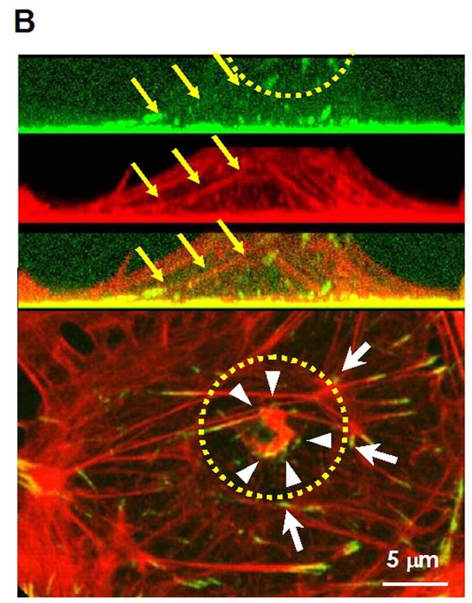
Illustration 1: An example of current stress fiber identification methodology.
“ (B) HUVECs were stained with anti-paxillin antibodies (upper panel) and Rhodamine-phalloidin (middle panel), and sectioned in the x-z plane. These images are overlaid in the panel below. The yellow semi-circle shows the position of the FN bead. Stress fibers (yellow arrows) connect the apical focal adhesions (FAs) to the basal FAs. The bottom panel shows the x-y confocal image of the cell. A 10 μm bead promoted formation of focal adhesions on the apical surface (shown by white arrows). The pattern of FAs underneath the FN bead was scattered and irregular (arrowheads). FAs on the cell base were also imaged. Twenty confocal images (5 μm thickness) were projected to the x-y plane.”

(Image and caption: Hayakawa et al 2007)

If sub-cellular feature quantification can be done with consistency over a broad range of cell types, features of interest, and types of microscopy, a larger quantity of information can be derived from microscopy data per hour of acquisition than currently used methods allow. Researchers could also begin creating hypotheses around cellular structures that depend on more complex variables. For example, rather than investigating whether or not a viral protein causes the formation of actin stress fibers in a cell, one could ask to what degree it causes the formation of stress fibers by characterizing length, eccentricity, number, and density of stress fibers – criteria that are difficult to identify reliably by visual observation alone.

Technical Obstacles
The primary challenges to overcome when writing a computer program that interprets visual data are fourfold. Primarily, ORCID must be able to discern features from background noise and intensity gradients. Secondly, it must be able to isolate individual features in the data in a way that agrees reasonably with human observation. Thirdly, it must be able to turn a large quantity of image and cluster data into a manageable quantity of numerical data that sufficiently represents the system in question. Finally, ORCID must be user accessible, meaning it can be used by untrained individuals who have little to no experience writing computer software, and it must not require more than a minimum of algorithm-steering user input.
As far as image preparation and filtering, ORCID must be able to distinguish a cluster of proteins from the general signal noise caused by the imaging device, and it must also be able to identify features against a variety of backgrounds (such as uniform gradients in the image intensity). This may be done through any number of filtering methods, depending on what features are to be analyzed. For example, a low pass, or blurring algorithm will reduce signal noise, but will also diminish the contrast of the feature edges. Alternatively, a high pass filter will reduce background gradients, but may also hollow out large features in an image. Because ORCID is intended to process a large variety of images it can be expected to need some of both filters in varying degrees of intensity depending on the incoming image properties, and it must be able to filter undesired signal while minimally corrupting the acquired data.
In order to identify features in a way that matches with a human's observations great care must be taken as to the type, method, and intensity of filtering that is done to each image. The algorithms associated with feature highlighting must take into account variations in overall image contrast and intensity range. Although intensity is important in data analysis, only relative intensity need be taken into account to identify features reliably within an image. This is demonstrable by examining three images of the same data (Figure 1). Even though all the images in Figure 1 have very different numerical data, the overall visual information is the same, and the same features can be identified by the unaided eye. ORCID must also be able to account for such variability.
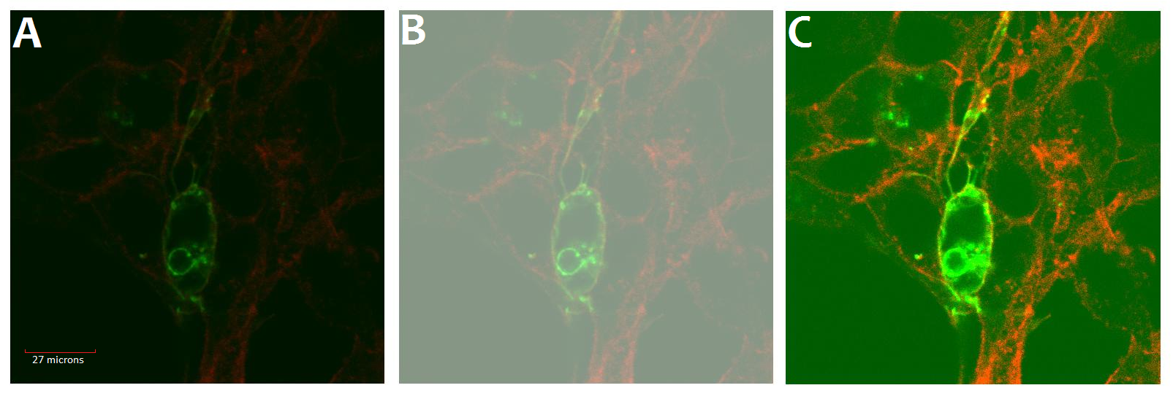Figure 1: Three images of the same source data. The first image (A) is the original image, whereas (B) is the same image offset in intensity, and (C) is the image value scaled by two times.
Once ORCID is able to successfully identify intracellular features while maintaining fidelity with what is observed by the naked eye, it must analyze each feature identified, which is done for each pixel of each cluster in each frame of each image. For a 30 frame image, the number of data points could be in the millions, so it is important for the program to be able to organize and summarize this information effectively for the end user in the most efficient way possible. That is, it must be able to represent all the pixel data information in a way that is concise, without losing too much meaningful information in the process.
The final obstacle to overcome is making such an intricate program run with minimal user input. Although many algorithms can identify cellular structures with high fidelity to our own observations, doing so without the guidance of an end user is significantly more difficult, and is pivotal to the objectivity of the process. The only point at which the user must be involved is during the output phase of the program, when it comes down to how the data is presented or organized. Within this requirement there is also the requirement that the program must be user friendly, with each piece of the interface well defined and described.

Fourier Filtering
Being able to isolate actual image data from background levels and noise is the most important part of the ORCID program. This is done through two combined methods, the first being the application of a bandpass Fourier filter to the image data (described later), and the second being a series of simple thresholding filters, the first eliminating blank space artifacts from the Fourier filter, and the second to extract the high intensity data from the filtered image (both described in detail later).
Figure 2 presents an example of Fourier filtering applied to an image of a fibroblast cell (Figure 2.A). The original image is constructed of many frequencies of spatial waves, like ripples on the surface of the pond. The Fourier transformation (Figure 2.C) tells us which waves make up the image, and how much each one contributes, with the longer waves in the middle, and the shorter ones near the edges (Lehar, 2007). We can thus approximate that most of the large features of our image are made of long waves, and are thus located in the middle of the Fourier transform. We also may suppose that most of the thin, small features are represented by the short frequency waves, which are on the edges of the Fourier transformation. All these frequencies combined (Figure 2.C) add up precisely to reconstruct the original image (Figure 2.A). Removing any of these frequencies (Figure 2.D) disrupts the balance of the transform, resulting in wave-like artifacts around the features of interest (Figure 2.B).
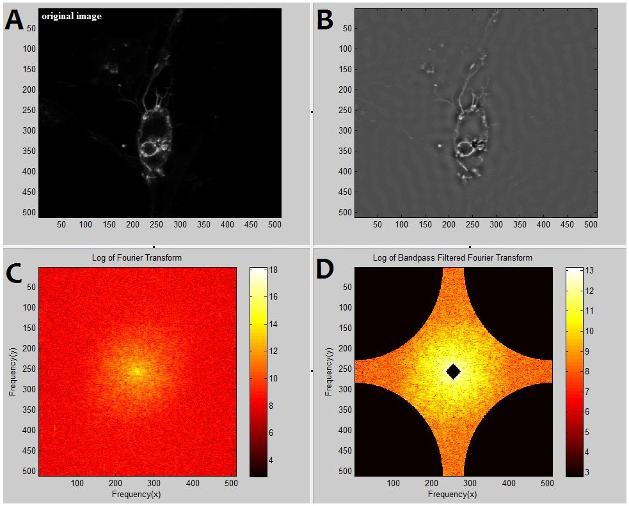Figure 2: The results of a bandpass Fourier filter on an image (A). Image (C) shows the original Fourier Transform shifted to center [256=0 frequency], while image (D) shows the same transform when masked with a circular bandpass filter, and then shifted to 256=0 frequency. Image (B) shows the resulting image recovered by inverse Fourier transforming image (D).(Scale is in pixels)
Note that, despite introducing wavelike artifacts into the image, the filter did not disrupt the general image information that was present in the original. This is because ORCID uses a set of filter radii that are especially tuned to eliminate background levels and noise without eroding the original features of interest (appendix A). Because the primary image features fall within the frequency range of the band pass filter, those features are preserved while the rest of the image falls into uncanceled harmonics. Note also that the regions bordering the primary image features are surrounded by dark troughs. This is another artifact of the Fourier filter, but it corresponds to an important feature of the inverted filtered transform. The sinusoids remaining in the filtered image are just barely out of phase, and as such they are constantly producing the harmonic artifacts throughout the blank space in the image (these artifacts I will refer to as 'blank space harmonics' as the discussion of filtering continues), however in the neighborhood of the main features (the features our selected frequencies best represent) the sin waves constructively interfere with many maxima occurring at the same time. This causes a peak of particularly high intensity pixels corresponding directly to the location of the desired image features. This effect can be mimicked in one dimension, as seen in Figure 3, and it is the most important part of the Fourier filter, because information away from the features of interest are disrupted while detail is preserved in the neighborhood of the important data.
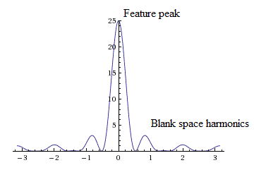Figure 3: One dimensional example of how sinusoids can create blank space harmonics and constructively interfere to create large feature peaks at the desired locations
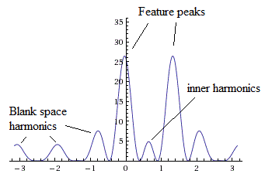Figure 4: Another example but with two adjacent feature peaks, illustrating the inner harmonics caused by interior spaces.
Fourier filtering necessitates a second type of filtering because the original information is now convoluted with the blank space harmonics. ORCID must now return to the original image to discern which regions of the image are of interest for analysis. This is achieved by generating a logical mask for the data (making a list of pixels to exclude) by evaluating the original image. The logical mask algorithm simply takes all pixels in the original image that are above a certain level (computed automatically) and saves them to an image. ORCID then fills in the blank spaces, and overlays the new mask (Figure 5) onto the Fourier filtered image, generating the final filtered image (Figure 6).
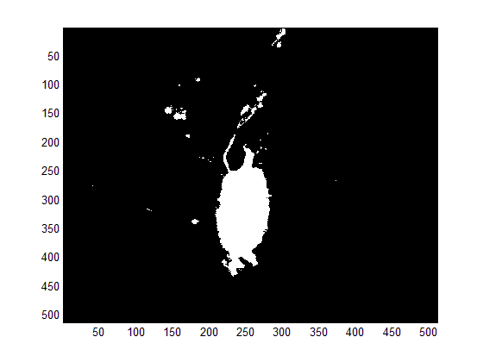Figure 5: Logical mask for the original image. White space means pixels in that region will be preserved, while black space means all data in that region will be discarded. This helps reduce the effect of blank space harmonics. The final result is Figure 6; (Scale is in pixels)
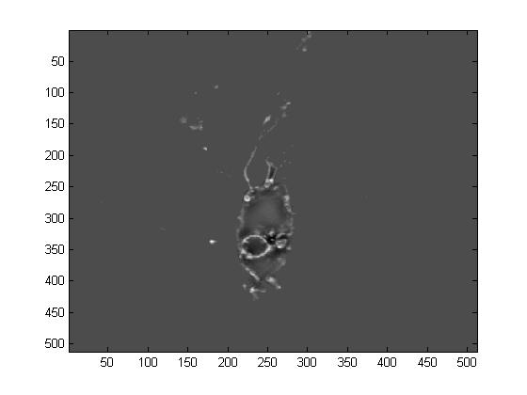Figure 6: The final filtered image with blank space harmonics removed. Notice that interior harmonics still exist within the image. (Scale is in pixels)
Once the blank space harmonics are eliminated, the Fourier filtering method is a stronger filter than doing a simple blurring or sharpening filter because it preserves detail with the highest fidelity near the features of interest while eliminating background levels and high frequency noise in other regions. In this way, many features of different intensities can be salvaged from the image without including noise or background that happens to fall in a higher than normal intensity range, which solves the first two problems stated earlier in this paper in the following ways: 1. The filter can eliminate noise and background before the analysis; and 2. The filter can recognize and preserve features of varying intensities that correctly correspond to what an observer sees with their unaided eyes. The only remaining step in the filtering process is to threshold the Fourier filtered image into a logical mask so that it can be analyzed by the cluster identification algorithm. To provide an example of the final output mask for both filtered and unfiltered examples, see Figure 7, below.
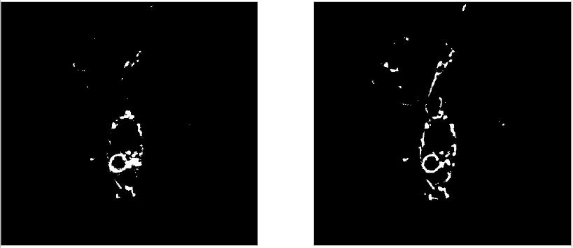Figure 7: A comparison of filtered, thresholded images. Without Fourier filter (right) and with Fourier filter (left). Notice that more features are defined in the filtered image, and with better edge preservation.
Cluster Identification
Once ORCID generates the thresholded image in the right image of figure 7, the two dimensional cluster identification process is fairly straightforward. The black-or-white image is passed to a built in MATlab function called 'regionprops', which generates a structure of variables that collect and characterize each pixel in the image. Pixels in the black and white image are simply connected to all neighboring pixels until no more can be added. This allows for the cluster identification code to be only a single line of this program, (which can be found in the program code; function: Update_clusters, on line 13). Each parameter of each cluster is found rather simply by this command. For example area is found by counting the number of pixels in each cluster, and eccentricity is found by fitting an ellipse to the cluster and measuring the length of the major axis compared to the distance between the ellipse's focci. The complete algorithmic procedures behind MATlab's 'regionprops' function are interesting, but are already well documented in the MATlab user guide (Appendix B). As a final output, 'regionprops' returns an N by 1 structure array, where N is the number of clusters in the frame. From this array, only the following fields are returned to the user: Eccentricity, Orientation, Area, Perimeter, Mean Intensity, and Cluster ID number. For mean intensity the standard deviation of pixel values can also be returned which can aid in error analysis, discussed later in this report.
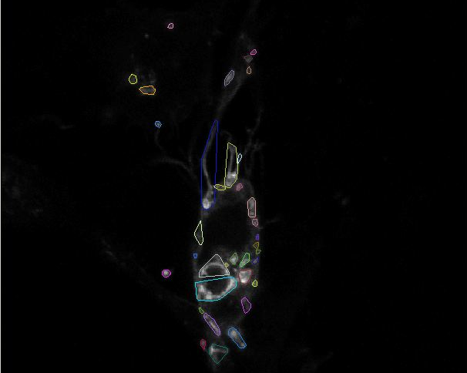Figure 8: Results from the cluster identification process. Identified clusters are outlined with convex, colored polygons which are overlaid onto the original image. Note that this is not the same frame of the image as in Figure 7, therefore the identified clusters are somewhat different.

The two dimensional analysis builds the foundation for three dimensional clustering and parametrization. Three dimensional analysis is important in cell biology to address questions of co-localization, surface area to volume ratios, or feature morphology. It also aids in collecting scattered cross sectional data into coherent, connected structures because many intracellular features are disconnected in x-y space, but connected by neighboring z-space clusters. Three dimensional analysis also has tho advantage of being able to describe an entire cell in one coherent three dimensional image rather than as discrete cross sections.
The basic algorithm works in much the same way as the 'regionprops' neighborhood identification algorithm, but rather than looking for neighboring pixels in x and y, ORCID looks for neighboring clusters in z. While conceptually this is a simple idea, algorithmically it is relatively complex. The program starts with an arbitrary cluster in the image from the first frame, and then scans up and down the image until no more neighbors can be found. Illustration 1 is a graphical representation of how this algorithm works in principle using rectangular clusters.
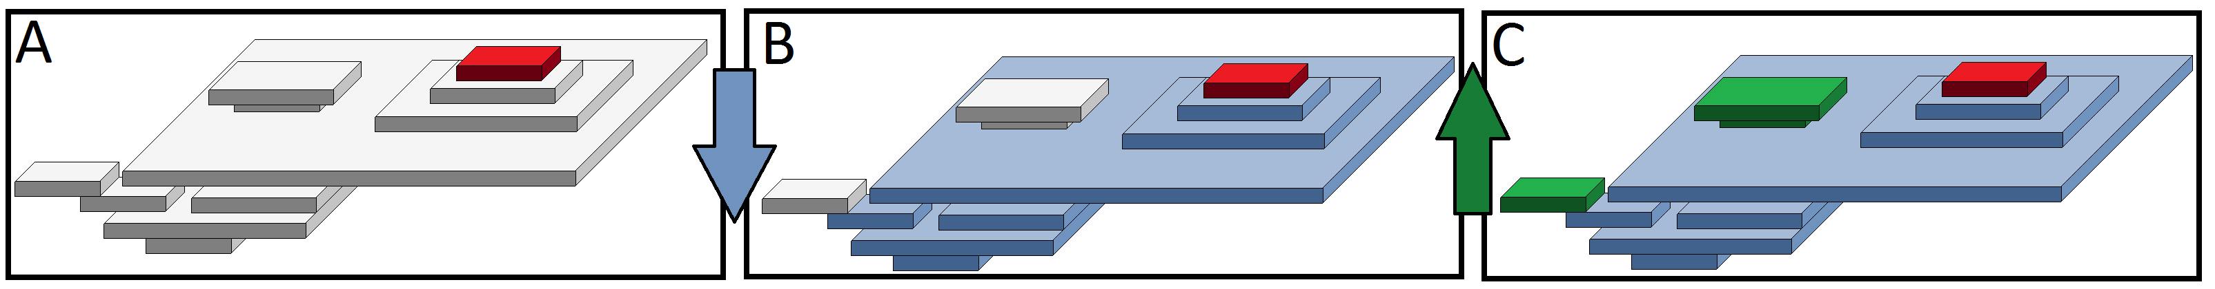Illustration 1: The 3D algorithm in ORCID begins with a single cluster (A, Red) and branches downward to connect adjacent clusters together (B, Blue). These connected clusters serve as the new 'mega cluster' template, from which the program branches upwards to find further connections (C, Green). This process is repeated until no new connections are found.

Three dimensional analysis has some strong advantages, although for some purposes it is still better to use two dimensional analysis. While three dimensional images are great for visualization (Figure 9), and can help answer questions related to location, surface area, and total volume, they are more difficult to analyze than two dimensional cross sections in general. From an algorithmic point of view, this means that the 3D analysis tool takes longer to run (on the order of 10 seconds to five minutes on a four core 3.4GHz CPU, depending on image size), which can be a limiting factor when speed is important or when advanced computer hardware is not available. On the data side of the program there is no procedure in ORCID for calculating eccentricity, orientation, or center of mass (center of brightness) in three dimensions. This results in a greater degree of difficulty in classifying the shapes output by the program in a numerical, quantifiable way. That being said, the 3D analysis tool is immensely powerful when examining the colocalization of two species of protein, examining hypothesis about surface area and volume, or when identifying the actual spatial locations of cross sections within the cell.
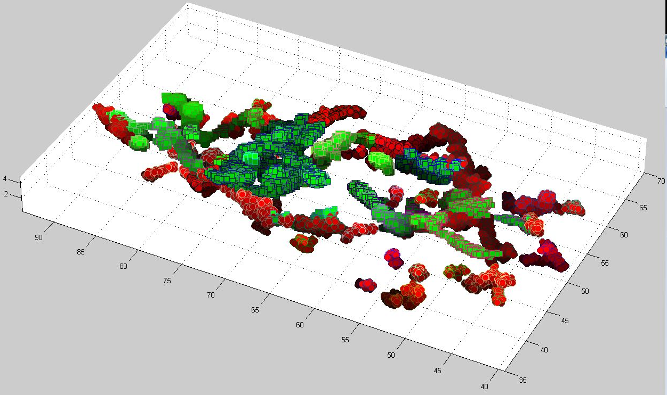Figure 9: An example of ORCID's Three dimensional clustering algorithm applied to the colocalizanion of a viral protein (Green squares) with filamentous actin (Red circles). Individual clusters are marked by points that have distinct edge colors. (Scale is in microns)
Data Filtering, Organization, and Quality Control
The data generated from these images is overwhelming, for both the ORCID program and the end user. A single frame of a 512 by 512 tiff image can generate anywhere between tens and hundreds of individual clusters, including between ten and one hundred thousand individual pixels total. Fortunately, the cluster identification algorithm returns averaged data for each cluster, as well as data that characterizes each cluster as a whole. Because, at the lowest level, the end user is most interested in data on the order of individual clusters, only the cluster-based data needs to be returned to the main program, while the pixel data is indexed and stored elsewhere should it be required again (standard deviation calculations etc.). Still, after culling the data up to the cluster level, there can be hundreds of clusters in each cell, so further steps are required to sufficiently summarize the data without losing generality.
Once cluster data has been generated, it must be filtered to eliminate two types of unwanted and erroneous data. First ORCID automatically eliminates clusters that are smaller than 10 pixels in total area. This limit is chosen because clusters containing any fewer than 10 data points do not contain enough information to be characterized with a reasonable degree of certainty (one additional pixel could change parameters by 10 percent or more depending on the parameter in question). The user may elect to ignore clusters larger than this during analysis, but the 10 pixel limit is a software/data limit that cannot be overcome. Between 20 and 50 percent of the identified clusters can be eliminated due to being too small (this varies from image to image). Next, as a misidentification safeguard, the program cross references each cluster with the original image, and discards clusters that have an average intensity that is lower than 10 percent of the data intensity range. For example, if a cluster has an average pixel value of 500, where the total data spans the space of 100 to 1600 intensity values, the cluster will be preserved. If the cluster had an average intensity 150 or less, however, it would be thrown away because such data is not meaningful to the naked eye (as it occupies only 10 percent of total image intensity range) and can be classified as a misidentification.
After these basic data filters have been applied, the program may still yield tens or low hundreds of clusters per frame. This may be significantly higher than the user is prepared to utilize, however the program cannot foresee what the user intends to do with the data at this point. They may wish to compare clusters within a single cell, or they may wish to analyze the cell as a whole by some other method. To facilitate further analysis, ORCID provides an easy to use spreadsheet exporting function that generates a spreadsheet document containing all of the remaining cluster data, along with summaries of the data for the entire cell. Below is a quick example of the numeric data that can be expected from a single frame image (Table 1).
Image_File_Name.tiff
Averages
Eccentricity | Orientation | Value | Area | Perimeter | Total clusters
0.849187 | -18.3806 | 195 | 34.92 | 29.07 | 45
Averaged Data std. deviations
0.173701 | 54.05754 | 17.64 | 6.515134 | 6.037169
Frame | Upper filter | Lower filter | Thresh | edge Rem. pix | um/pix
1 | 0.96 | 0.63 | 0.4 | 0 | 0.212
Cluster Data
Eccentricity | Orientation | Value | Area | Perimeter | ID
0.915252 | -16.067 | 76 | 16 | 15.07107 | 1
0.859160 | 87.52 | 159 | 345 | 390.61 | 2
... | ... | ... | ... | ... | ...
Table 1: An example numeric data output from ORCID, with summaries of data in the first three columns, followed by the individual cluster data (truncated to two clusters here)

The automatically calculated averages and standard deviations aid in generalizing individual cluster data through the entire cell. If the user is interested in looking at individual clusters, a complete parameter list is located just below the summaries (final three rows of Table 1). Ultimately this is the numeric, quantified data that can be used to identify features based on actual structure parameters rather than by rough qualifications evaluated by eye. The above table is also available in-program, which is useful for generating graphics because ORCID renders any clusters highlighted in the program's spreadsheet so that they may be captured for individual classification ( as seen in Figure 10, on the rightmost panel).

User Input and Parameter Bias
The interaction between the ORCID graphic user interface and the end user is very important in the analysis process. Above all, ORCID must be easy to use and understand given limited technical experience with the inner workings of the program (or program code in general). ORCID must also require only what is absolutely necessary from the user in the way of analysis-steering parameters to prevent user bias from changing the output data. Finally, ORCID must present the data back to the user in a way that is clear and correct with a clear way for the user to check whether or not the output data is reasonable. Maintaining each of theses three elements in a program can require significant work, and may not be possible under certain conditions. These three features: accessibility, consistency, and integrity, are each implemented into the ORCID program successfully.
The ORCID graphic user interface (GUI) (Figure 10) is the primary interactive component of the ORCID program. This is what the user sees at all times; where they obtain data, and where they set up the analysis. Special care has been taken to make the GUI as user friendly as possible, exposing the most amount of functionality as possible while presenting the user's options in a clear, logical way. The analysis begins at the top of the window where the user selects a file to load, and then proceeds down and to the right as the user completes each step (the same way one would read a book). Buttons and inputs that should not be pressed at any given point are grayed-out so that the user is is guided to follow the program's execution in this way. For example when the user begins the program, nearly everything is grayed out except the 'Load Image File' button, which, when pressed, enables the Fourier filtering fields and buttons (which activate the cluster analysis buttons and so on). A program that is easy and intuitive to use often has a much shorter learning curve, and thus reduces operator error during analysis.
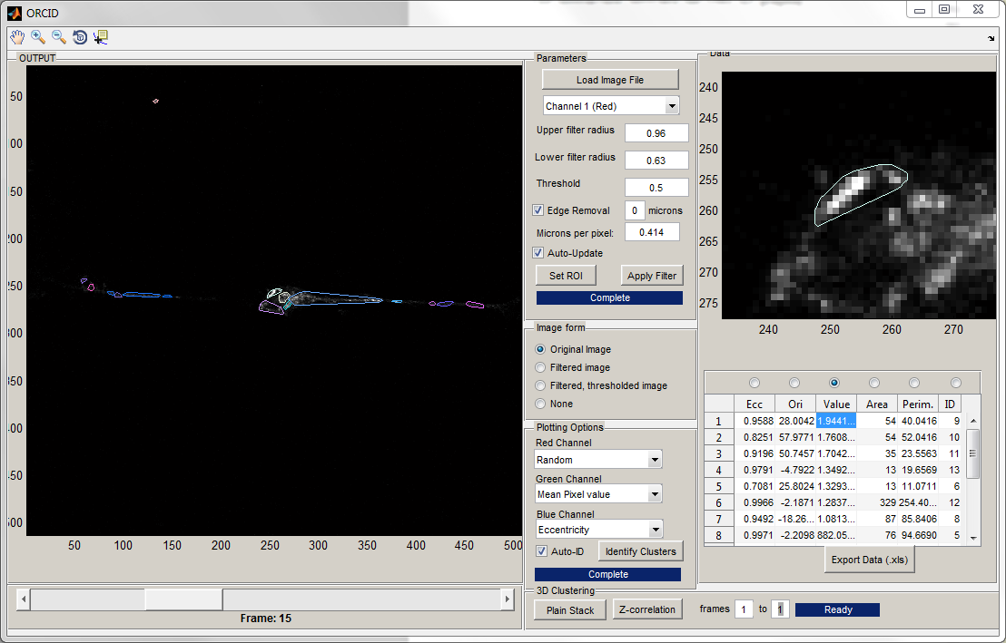Figure 10: The ORCID graphical user interface (GUI). The program has analyzed a single frame (frame 15) of a multi-frame tiff image. An example cluster is highlighted in the upper right while the entire cell is shown in the main display.
The user is presented with three algorithm-modifying parameters during setup: Upper filter radius, lower filter radius, and threshold. The first two parameters, 'Upper Filter Radius' and 'Lower Filter Radius', define the limits of the bandpass filter that is pivotal to ORCID's cluster identification process. The default values (0.96 and 0.63) have been established experimentally as the optimal filter levels for over 30 multiple frame images of fibroblast cells gathered by confocal microscopy (See appendix A for more detailed information), however under certain conditions additional tweaking of the filter levels is required. Normally the tweaking is very small (plus or minus 0.01) however with different image formats and specimen, the changes may need to be larger (+/- 0.05 for upper, +/- 0.3 for lower). Because there is not yet any algorithm to correctly calculate what filter ranges should be used, these parameters are left exposed to the user to allow for more flexible and accurate analysis. The third parameter, the threshold, depends on the image intensity range and data type. There is already an algorithm to correctly determine the threshold level, but because the program requires a threshold percentage (as opposed to an intensity value), the image data maximum must be known (ie, bmp images could have intensities ranging from 0-256 or 0-2048 depending on their bit depth and number of channels – even if no pixels actually occupy the maximum intensity space). A simple way to correlate file format with maximum possible intensity level has not been found, therefore the threshold has also been left as a manual setting to allow for better user control.
The effect of these exposed controls is a double edged sword. It gives the user more control over analysis, and thus the identification algorithm works more precisely, but it also puts a degree of control into the users' hands that could skew scientific results if used improperly. Constant filtering values are imperative when testing a hypothesis related to any of the parameters classified by ORCID. Even though some filter ranges may characterize what the user sees better in one image than in another, changing the filtering values between images during an experiment can drastically compromise the outcome of analysis. Ideally, the user will take a series of images and test each one with default filtering ranges, looking for image coherence and quality feature recognition. This will often be sufficient, and the user may begin cluster parametrization, but if tweaking is required, each filter must be adjusted and testing must be restarted from the beginning before analysis continues. Once image processing and data collection has begun, no filter parameters should be changed. Under these circumstances, an initial bias will be present depending on how the user decides to set up the filtering values, but the bias will remain constant throughout the experiment. As a result, when two images, clusters, or data sets are compared, the bias will be present in both, and any general differences between the two pieces of data may be concluded to come from the data itself. Effectively this is like any other experiment in which multiple free variables are held constant to isolate the data required to test a hypothesis.

Assessing Erroneous Cluster Identification
When analyzing raw data like the images from a microscope, it is difficult to define what does and does not constitute an erroneous cluster identification. The first issue is that ORCID was developed under the premise that cluster identification is best done by a computer, however the easiest way to qualify whether or not a cluster is legitimate is by comparing what ORCID returns with the original image by eye. This is not possible to do on the same timescale as a single identification (or with the same reliability), and it defeats the original purpose of autonomous cluster identification. Thus ORCID must be able to not only define clusters in an image, but it must also be able to decide whether or not it has been successful, and then beyond that, give the user the tools to objectively judge for themselves after the fact. This is done primarily through pixel intensity information on a cluster by cluster basis. As mentioned in Data Filtering, Organization, and Quality Control earlier in this paper, clusters of a certain size (less than ten pixels) and brightness (less than ten percent of total) are immediately classified as erroneous and removed before the user is presented with the data. Other issues, however, like identifying only partial clusters, including blank space around legitimate clusters, and merging adjacent clusters, must be addressed by the algorithm.
Ultimately ORCID addresses these issues by including uncertainty measurements in each of it's parameter readouts. Exemplified in Table 1 earlier, standard deviation measurements as well as mean values are returned to the user on a cluster by cluster basis. This information can be used at the digression of the experimenter- that is- it is up to the user to decide what qualifies a legitimate cluster based on numerical outputs rather than on the image data itself. This is the major benefit of analyzing data with ORCID; the user is no longer trapped in the subjective realm of by-eye identification and can now define clusters by hard numbers. For example, they may decide that for one experiment, an erroneous cluster is any cluster with an intensity standard deviation of 25.6 or more, or perhaps any clusters with fewer than 50 pixels. Furthermore, so long as the same standards are kept between images in one experiment, errors in cluster identification become less influential on results as the sample size increases.

Conclusion
The ORCID computer program provides a way to objectively analyze cellular image data in both two and three dimensions. It is capable of parametrizing two dimensional images in terms of cluster size, eccentricity, orientation, average pixel intensity, area, perimeter, position, and number, while defining 3D structures in terms of surface area, volume, and voxel intensity per volume. This is done through Fourier bandpass filtering, basic image thresholding, various data protection masks, and quality control filters to ultimately produce tabulated data in the form of a spreadsheet to the end user. ORCID is also capable of producing useful graphical data with it's many plotting options, representing 2 and 3 dimensional data in a way that is easy to understand.
The primary usefulness of ORCID is in comparative analysis. When multiple image sets, images, or clusters must be quantitatively compared, cluster misidentification and user input bias can be mitigated by utilizing a large sample size. Even though ORCID only removes a small portion of all possible erroneous data, information such as standard deviations, mean intensities, and sizes are all returned to the user to allow for quantitative results criteria that can be varied as needed from experiment to experiment. In this way ORCID can be used in cell biology to investigate hypothesis of quality based on quantitative data rather than testing binary hypothesis based on subjective judgements, and it may even be used to derive novel information from data to aid in the formation of new hypotheses.
Ultimately, ORCID satisfies the requirements noted at the beginning of this paper. It is reasonably easy to use, it is able to reliably identify intracellular data against background gradients and noise, and it successfully collapses large quantities of data into manageable, functional units with minimal loss of generality. As it is developed further, it may be able to analyze data without any user input, at which point objective data on individual images could be universally compared to other data derived by the same program. At this point, however, it is sufficient to say that ORCID is an extremely useful utility, and will hopefully continue on to aid in the efficiency of scientific developments throughout the labs here at the university.
Works Cited:

Lehar, S., 2007, An Intuitive Explanation of Fourier Theory http://sharp.bu.edu/~slehar/fourier/fourier.html (Accessed on September 28, 2011)

Hayakawa, K., Tatsumi, H., Sokabe, M., 2008, Actin stress fibers transmit and focus force to activate mechanosensitive channels, Advance Online Publication February 15, 2008 J Cell Sci 121, 496-503. http://jcs.biologists.org.prxy4.ursus.maine.edu/content/121/4/496.full

Weisstein, Eric W. "Fast Fourier Transform." From MathWorld--A Wolfram Web Resource. http://mathworld.wolfram.com/FastFourierTransform.html

Appendix A: Default Parameter Exploration
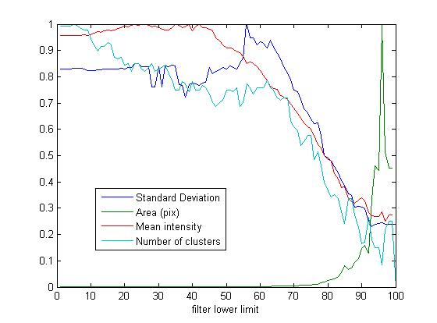 | 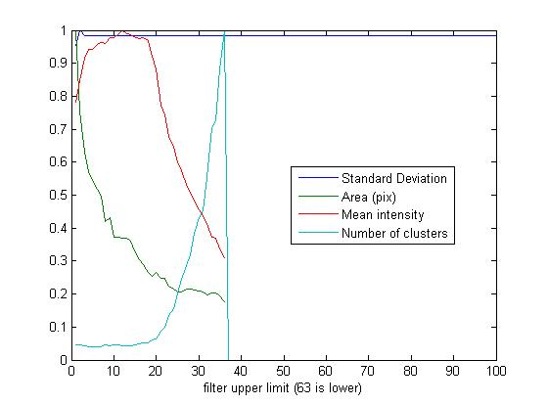
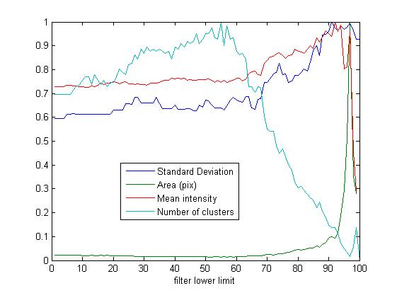 | 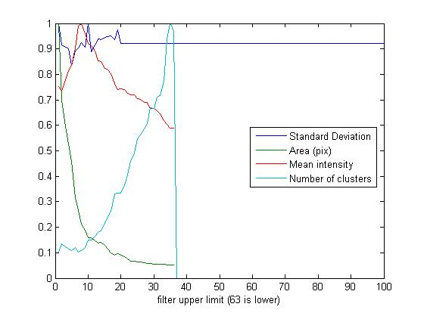
Figure 11: A sampling of (normalized) graphs used to identify optimal values for the Fourier filter ranges. Values were chosen based on general trends in the curves, particularly with the lower filter (left) where mean intensity, standard deviation, and number of clusters begin to fall off rapidly. The upper filter (right) was analyzed with the accepted lower filter default value (0.63, or 63 in the above scale) and the optimal value was chosen based on the mean intensity of clusters approaching a peak (at roughly 4, yielding the default value 0.96, or 100-4 in the above scale). Values were then tested by eye and confirmed to be optimal under most circumstances (~30 confocal tiff stacks).

Appendix B

ORCID USER GUIDE

This guide will help you through the data analysis process, from determining proper filter parameters to extracting meaningful data as quickly as possible.

Step 1:
Loading a file and setting up image parameters
During this step, refer to Step 1.A to check your work.

Load an image file by clicking the “Load Image File” button at the top of the parameters panel. You may load any of the following:
Tagged Image File Format (.tiff), Graphics Interchange Format (.gif), Portable Network Graphic (.png), JPEG (.jpg), Bitmap (.bmp)
The Tagged Image File format is highly recommended for analysis.

Adjust the threshold:
For most images, the default filter radii settings should be adequate for feature identification. Tweaking these parameters should take place after setting an appropriate threshold. Below is a file format-specific list of recommended thresholds:
.tiff (multi-tiff or single frame) – Threshold: 0.9
.gif (animated or single frame) – Threshold: 0.05-0.1
.png – Threshold: 0.05-0.5
.jpg – Threshold: 0.03-0.2
.bmp – Threshold: 0.05-1.0

These thresholds should be adequate for most images, but make sure to adjust the threshold so that all of what you see with your eye is preserved. Having a threshold that is too high will give an image with many missing features, or no features at all. Having a threshold that is too low will give an image that highlights dark features that are barely visible to the naked eye.

Set the Region of interest This is important if you have multiple cells in one image but only want to analyze one of them. BE GENEROUS with your region of interest. Select the largest region that you can without including other cells, then right click the image and select “create mask” to create a region of interest. (applies to all frames)

If your images still have misidentifications in them, it may be necessary to adjust the filter radii. Check the troubleshooting guide on the next page.
Troubleshoot:
- Artifact clusters (clusters that do not correspond to anything in the image) appear in large empty regions, usually repeating structures or wave-like features
  - Upper filter radius should be increased
    - OR: Threshold should be increased
  - Edge removal should be enabled, even if edge removal is set to zero microns.
- Features are too smooth or bleed into each other
  - Distance between upper and lower filter is too small. Either increase the upper filter or decrease the lower filter.
- Many tiny noise-like features
  - Increase the lower filter radius
    - OR: Increase the threshold.

Step 1.A:
Checking your Parameters as you go

It isn't always easy to check If your parameters are working properly. If you want a quick preview of the clusters any set of parameters will give you, click on the “Filtered, Thresholded image” radio button. Compare this with the “Original Image” radio button to see if your filter is working (highlighted features match what you see). If it's not working, look at “Filtered Image” to see what sort of artifacts are being generated, and if your filter is failing because of threshold values, or upper/lower filter radius.

Step 2:
Identifying Clusters

Identifying clusters is easy once you set up your filter. Simply click the “Identify Clusters” button. If you want to have special graphing colors depending on certain aspects of your clusters, you can assign special plotting options to each color channel. For example, if you wanted your biggest clusters to be red and the smallest ones to be black, you would set “Red channel” to “Area” and set the other two channels to “off”. If you wanted your most eccentric clusters to be yellow and your least eccentric clusters to be green, set “Red Channel” to “Eccentricity”, set ”Green Channel” to “on” and set “Blue Channel” to “off”. There are many more possible combinations, and random is the default color setting for each channel. Check the “Auto-ID” button if you want the clusters to be re-identified every time you change something (Warning! This can be pretty slow if you are changing parameters or frames frequently).

Step 3:
Interpreting and Exporting Data

ORCID returns a large quantity of data from each image analysis, so understanding the output is extremely important. The first type of data you will encounter is the graphical data displayed in the main plotting window. It consists of convex polygons outlining each cluster identified by the program. A convex polygon will not conform to concave cluster features to reduce the load on the computer's CPU, which is sort of like wrapping a rubber band around the cluster. Do not confuse this outline with the actual cluster pixels themselves, which can be viewed by selecting the “Filtered, Thresholded image” graphing option outlined in step 1.A.

The second data output type is the tabulated data in the lower left hand corner of the window. This is the numerical data that classifies each cluster (rows) by different parameters (columns). Currently there are fields for Eccentricity, Orientation, Mean Pixel value, Area, Perimeter, and ID number, where the ID number is simply a tag to keep track of each cluster throughout the analysis process.

When rows are highlighted in the tabulated data window, the corresponding clusters will be drawn individually in the preview window (upper right). You may select individual or multiple clusters to generate graphics corresponding to data points of interest. Be warned that selecting clusters by dragging the cursor across many data points will re-render each cluster every time a cell is added, so be prepared for program slowdown while selecting an indeterminate number of clusters. To avoid such slowdown, select individual clusters by control-clicking cells, or select groups by shift-clicking on cells.

Tabulated data may be exported by clicking the “Export data” button, which generates a Microsoft spreadsheet document (If Microsoft office is not available, a generic spreadsheet document is generated.) Cells may also be copied individually from the program window into Microsoft office. Exported data also contains some additional information that can be calculated from the individual cluster data. Along with information about each cluster, the program outputs average data for the entire cell along with the standard deviations of that data.

Step 3.A:
Three dimensional Analysis:

ORCID has built-in functionality for generating 3D data from a multiple frame image. Once the image is loaded, you may select either “Plain Stack” to get a quick overview of cluster morphology, or “Z-correlation” to get a detailed, parametrized analysis of voxel neighborhoods in the stacked image. When selecting “Plain Stack” be sure to specify a frame range that you wish to render. When selecting “Z-correlation” the program will prompt you for the number of species, and frame ranges for each species to identify within the image. Multi-species analysis is based on multiple frame tiff images in which each channel is separated into its own frame stack, so a 20 frame RGB image would actually contain 60 frames of gray-scale image data. ORCID treats each cluster in the first range of frames as species one (green) and each cluster in the second range of frames as species two (red). There is currently no support for more than two species.

Data output for three dimensional analysis is very similar to the two dimensional output. The user is presented with graphical and tabulated data. An example of the graphical data is shown here. Each species can be clearly identified by the green and red coloring, and each cluster within each species can be identified by the uniquely colored borders on each data point.
Appendix C
Full code Transcript

Contents:
- ORCID …......................................................................30
- F_CT3D …....................................................................41
- fourier_update ...............................................................43
- FourierFilter …............................................................. 43
- Update_All_data ...........................................................44
- update_cluster_plot .......................................................44
- Update_Clusters …....................................................... 45
- update_display …......................................................... 46
- Update_Fourier_Complete .......................................… 47
- Zspace_Megacluster …................................................. 47

Referenced earlier in this paper: 'regionprops' execution, page 46, line 10.

ORCID

function varargout = ORCID(varargin)
gui_Singleton = 1;
gui_State = struct('gui_Name', mfilename, ...
'gui_Singleton', gui_Singleton, ...
'gui_OpeningFcn', @ORCID_OpeningFcn, ...
'gui_OutputFcn', @ORCID_OutputFcn, ...
'gui_LayoutFcn', [] , ...
'gui_Callback', []);
if nargin && ischar(varargin{1})
gui_State.gui_Callback = str2func(varargin{1});
end

if nargout
[varargout{1:nargout}] = gui_mainfcn(gui_State, varargin{:});
else
gui_mainfcn(gui_State, varargin{:});
end
function ORCID_OpeningFcn(hObject, eventdata, handles, varargin) %#ok<*INUSL>
handles.output = hObject;
channeloptions={'Standard deviation' 'Mean Pixel value' 'Area' 'Random' 'on' 'off' 'Orientation' 'Eccentricity'};
set(handles.popupredchannel,'string',channeloptions)
set(handles.popupredchannel,'value',4)
set(handles.popupgreenchannel,'string',channeloptions)
set(handles.popupgreenchannel,'value',4)
set(handles.popupbluechannel,'string',channeloptions)
set(handles.popupbluechannel,'value',4)
set(handles.popupchannel,'string',{'Channel 1 (Red)' 'Channel 2 (Green)' 'Channel 3 (Blue)'})
set(handles.radiooriginal,'Enable','off')
set(handles.radiofilter,'Enable','off')
set(handles.radiofilterthresh,'Enable','off')
set(handles.radionone,'Enable','off')
set(handles.frameslider,'Enable','off')
set(handles.regionpropsbutton,'Enable','off')
set(handles.applybutton,'Enable','off')
set(handles.ROIbutton,'Enable','off')
set(handles.ZstackClusterButton,'Enable','off')
set(handles.stack3dbutton,'Enable','off')
set(handles.slidertext,'string','Frame: 1')
handles.path=cd;
handles.channel=1;
handles.FILTEREDIMAGE=imread('TESTIMAGE.png');
handles.IMAGEINPUT=imread('TESTIMAGE.png');
handles.ROImask=zeros(size(handles.IMAGEINPUT))+1;
handles.graphtype=handles.radiooriginal;
handles.threshold=0.5;
set(handles.thresholdtext,'string',num2str(handles.threshold))
handles.autoupdate=0;
handles.autoid=0;
handles.currentframe=1;
handles.redgraph=4;
handles.greengraph=4;
handles.bluegraph=4;
handles.coords=[];
handles.rgb=[0 0 0];
handles.mikestopix=0.212;
handles.vmikestopix=0.45;
handles.edgemask=str2double(get(handles.edgeremovetext,'String'));
handles.stackrange(1)=1;
handles.stackrange(2)=1;
handles.INFO=[];
handles.datamode=0; %change this to 1 when you get 3D data
%colormap('gray')
% handles.appendnumber=0;
addpath('subfunctions');
% Update handles structure
guidata(hObject, handles);
function varargout = ORCID_OutputFcn(hObject, eventdata, handles)
% varargout cell array for returning output args (see VARARGOUT);
% hObject handle to figure
% eventdata reserved - to be defined in a future version of MATLAB
% handles structure with handles and user data (see GUIDATA)

% Get default command line output from handles structure
varargout{1} = handles.output;
function loadbutton_Callback(hObject, eventdata, handles) %#ok<*DEFNU>
[a b c]=uigetfile({'*.*'},'Select a file to load', ...
'Multiselect','off',handles.path);
if c==1;
colormap gray;
handles.fname=a;
handles.path=b;
set(handles.radiooriginal,'Enable','off')
set(handles.radiofilter,'Enable','off')
set(handles.radiofilterthresh,'Enable','off')
set(handles.radionone,'Enable','off')
handles.IMAGEINPUT=imread([handles.path handles.fname]);
tempvar=size(handles.IMAGEINPUT);
handles.ROImask=zeros(tempvar(1),tempvar(2))+1;
imagesc(handles.IMAGEINPUT,'parent',handles.axes1)
handles=Update_All_Data(handles);
set(handles.frameslider,'Enable','off')
set(handles.regionpropsbutton,'Enable','off')
%
set(handles.applybutton,'Enable','on')
set(handles.ROIbutton,'Enable','on')
set(handles.ZstackClusterButton,'Enable','on')
set(handles.stack3dbutton,'Enable','on')
%%FIND the scale automatically
try
ftext=[handles.path handles.fname(1:end-4) '.txt'];
str=fscanf(fopen(ftext),'%s');
str=str((strfind(str,'XDimension')):end);
commas=strfind(str,',');
str=str((commas(2)+1):end);
str=str((1:strfind(str,'[um/Pixel]')-1));
disp('Automatically found image scale:')
disp([str ' microns per pixel'])
set(handles.mikestopixtext,'String',str)
handles.edgemask=str2double(get(handles.edgeremovetext,'String'))/handles.mikestopix;
%now find z scaling
str=fscanf(fopen(ftext),'%s');
str=str((strfind(str,'ZDimension')):end);
commas=strfind(str,',');
str=str((commas(2)+1):end); %go to the second comma after the string
str=str((1:strfind(str,'[um/Slice]')-1));%read until you arrrive at the units
handles.vmikestopix=eval(str);%turn string to a number
disp('Automatically found slice depth')
disp([str ' microns per slice'])
catch error
disp(error)
end
%%End finding scale
imageinfo=imfinfo([handles.path handles.fname]);
handles.numframes=length(imageinfo); %find dimensionality of image
handles.hardmax=2^max([imageinfo.BitDepth]);
if handles.numframes>1;
set(handles.frameslider,'Enable','on');
set(handles.frameslider,'SliderStep',[1/(handles.numframes-1) 10/(handles.numframes-1)])
end;

% %Auto threshold
% for i=1:handles.numframes;
% if i==1; IMIN=imread([handles.path handles.fname]); end;
% if i>1; IMIN=imread([handles.path handles.fname],'index',i); end;
% maxval(i)=max(max(IMIN(:,:,handles.channel)));
% minval(i)=min(min(IMIN(:,:,handles.channel)));
% end;
% threshval=min(minval)+(max(maxval)-min(minval))/10;
% disp(hardmax)
% threshval=threshval/hardmax;

end;
guidata(hObject, handles);
function frameslider_Callback(hObject, eventdata, handles) %#ok<*INUSD>
set(handles.radiooriginal,'Enable','off')
set(handles.radiofilter,'Enable','off')
set(handles.radiofilterthresh,'Enable','off')
set(handles.radionone,'Enable','off')
set(handles.regionpropsbutton,'Enable','off')

handles.frame=floor(get(hObject,'Value')*(handles.numframes-1))+1;
handles.IMAGEINPUT=imread([handles.path handles.fname],handles.frame);
imagesc(handles.IMAGEINPUT,'parent',handles.axes1)
set(handles.slidertext,'string',['Frame: ' num2str(handles.frame)])
drawnow;
handles=Update_All_Data(handles);
guidata(hObject, handles);
function frameslider_CreateFcn(hObject, eventdata, handles)
if isequal(get(hObject,'BackgroundColor'), get(0,'defaultUicontrolBackgroundColor'))
set(hObject,'BackgroundColor',[.9 .9 .9]);
end
function popupbluechannel_Callback(hObject, eventdata, handles)
handles.bluegraph=get(hObject,'value');
handles=Update_Clusters(handles);
guidata(hObject, handles);
function popupbluechannel_CreateFcn(hObject, eventdata, handles)
if ispc && isequal(get(hObject,'BackgroundColor'), get(0,'defaultUicontrolBackgroundColor'))
set(hObject,'BackgroundColor','white');
end
function popupgreenchannel_Callback(hObject, eventdata, handles)
handles.greengraph=get(hObject,'value');
handles=Update_Clusters(handles);
guidata(hObject, handles);
function popupgreenchannel_CreateFcn(hObject, eventdata, handles)
if ispc && isequal(get(hObject,'BackgroundColor'), get(0,'defaultUicontrolBackgroundColor'))
set(hObject,'BackgroundColor','white');
end
function popupredchannel_Callback(hObject, eventdata, handles)
handles.redgraph=get(hObject,'value');
handles=Update_Clusters(handles);
guidata(hObject, handles);
function popupredchannel_CreateFcn(hObject, eventdata, handles)
if ispc && isequal(get(hObject,'BackgroundColor'), get(0,'defaultUicontrolBackgroundColor'))
set(hObject,'BackgroundColor','white');
end
function upperfiltertext_Callback(hObject, eventdata, handles)
handles.upperR=str2double(get(hObject,'string'));
handles=Update_All_Data(handles);
guidata(hObject, handles);
function upperfiltertext_CreateFcn(hObject, eventdata, handles)
set(hObject,'string','0.96')
handles.upperR=str2double(get(hObject,'string'));
guidata(hObject, handles);
if ispc && isequal(get(hObject,'BackgroundColor'), get(0,'defaultUicontrolBackgroundColor'))
set(hObject,'BackgroundColor','white');
end
function lowerfiltertext_Callback(hObject, eventdata, handles)
handles.lowerR=str2double(get(hObject,'string'));
handles=Update_All_Data(handles);
guidata(hObject, handles);
function lowerfiltertext_CreateFcn(hObject, eventdata, handles)
set(hObject,'string','0.63')
handles.lowerR=str2double(get(hObject,'string'));
guidata(hObject, handles);
if ispc && isequal(get(hObject,'BackgroundColor'), get(0,'defaultUicontrolBackgroundColor'))
set(hObject,'BackgroundColor','white');
end
function thresholdtext_Callback(hObject, eventdata, handles)
handles.threshold=str2double(get(hObject,'string'));
handles=Update_All_Data(handles);
guidata(hObject, handles);
function thresholdtext_CreateFcn(hObject, eventdata, handles)
handles.threshold=str2double(get(hObject,'string'));
guidata(hObject, handles);
if ispc && isequal(get(hObject,'BackgroundColor'), get(0,'defaultUicontrolBackgroundColor'))
set(hObject,'BackgroundColor','white');
end
function popupchannel_Callback(hObject, eventdata, handles)
handles.channel=get(handles.popupchannel,'value');
%Change channel above and update fourier below:
handles=Update_All_Data(handles);

guidata(hObject, handles);
function popupchannel_CreateFcn(hObject, eventdata, handles)
if ispc && isequal(get(hObject,'BackgroundColor'), get(0,'defaultUicontrolBackgroundColor'))
set(hObject,'BackgroundColor','white');
end
function uipanel4_SelectionChangeFcn(hObject, eventdata, handles)
handles.graphtype=eventdata.NewValue;
handles.graphimage=update_display(handles.graphtype,handles);
imagesc(handles.graphimage,'parent',handles.axes1)
handles=Update_Clusters(handles);
try handles=update_cluster_plot(handles); end;
guidata(hObject, handles);
function applybutton_Callback(hObject, eventdata, handles)
handles=fourier_update(handles);
handles.graphimage=update_display(handles.graphtype,handles);
imagesc(handles.graphimage,'parent',handles.axes1)
handles=Update_Clusters(handles);
guidata(hObject, handles);
function checkboxauto_Callback(hObject, eventdata, handles)
handles.autoupdate=get(hObject,'Value');
guidata(hObject, handles);
function regionpropsbutton_Callback(hObject, eventdata, handles)
BEF=handles.autoid;
handles.autoid=1;%oops, this is just to make the following function work.
handles=Update_Clusters(handles);
handles.autoid=BEF;%reset to whatever it was before.
guidata(hObject, handles);
function checkboxautoID_Callback(hObject, eventdata, handles)
handles.autoid=get(hObject,'value');
guidata(hObject, handles);
function edgemaskbox_Callback(hObject, eventdata, handles)
handles.edgemask=get(hObject,'value');
if handles.edgemask==1;
handles.edgemask=str2double(get(handles.edgeremovetext,'String'))/handles.mikestopix;
else
handles.edgemask=-1;
end;
handles=Update_All_Data(handles);
guidata(hObject, handles);
function uitable1_CellSelectionCallback(hObject, eventdata, handles)
if handles.datamode==0;
set(hObject,'ColumnName',{'Ecc';'Ori';'Value';'Area';'Perim.';'ID' })
try %#ok<*TRYNC>
%the following block sometimes messes up when organizing the list
cell=eventdata.Indices;
data=get(hObject,'Data');
inds=data(cell(:,1),end);
handles.cellinds=inds;
%coords=cat(1,handles.STATS(inds).PixelList);
%plot(coords(:,1),max(get(handles.axes1,'Ylim'))-coords(:,2),'.','color',[0 0 0],'parent',handles.axes2)
% hold on
% axis equal
% set(handles.axes2,'Xlim',get(handles.axes1,'Xlim'))
% set(handles.axes2,'Ylim',get(handles.axes1,'Ylim'))
% hold off

imagesc(handles.graphimage,'parent',handles.axes2)
hold on
hulls=[];
for ii=1:length(inds);
%rectangle('position',handles.STATS(inds(ii)).BoundingBox,'edgecolor','red','parent',handles.axes2)
hull=handles.STATS(inds(ii)).ConvexHull;
col=[handles.RGB(inds(ii),1) handles.RGB(inds(ii),2) handles.RGB(inds(ii),3)];
plot(hull(:,1),hull(:,2),'color',col,'parent',handles.axes2)
hulls=cat(1,hulls,hull);
end;
axis equal
border=(max(hulls(:,1))-min(hulls(:,1)));
set(handles.axes2,'Xlim',[min(hulls(:,1))-border max(hulls(:,1))+border])
set(handles.axes2,'Ylim',[min(hulls(:,2))-border max(hulls(:,2))+border])
hold off
end;
end;
if handles.datamode==1;
set(hObject,'ColumnName',{'Volume';'Surface';'ID';'Brightness';' ';' ' })
%the following block sometimes messes up when organizing the list
ax=handles.axes2; %#ok<*NASGU>
%maxcoord=max(cat(1,cat(1,handles.MegaCluster.xx),cat(1,handles.MegaCluster.yy)))*handles.mikestopix;
%mincoord=min(cat(1,cat(1,handles.MegaCluster.xx),cat(1,handles.MegaCluster.yy)))*handles.mikestopix;
%zmin=min(cat(1,MegaCluster.zz))*handles.mikestopix;
%zmax=max(cat(1,MegaCluster.zz))*handles.mikestopix;
%zrange=(zmax-zmin);
%axis([mincoord maxcoord mincoord maxcoord zmin-zrange*2.5 zmin+zrange*2.5 0 1])
%teh above line sets the axis to span all image space, and then scale z
Rind=0; %This index is used in the data refinement
%plot the data!
inds=1;
cell=[eventdata.Indices(:,1)]';
data=get(hObject,'Data');
inds=[data(cell,3)]';
disp(inds)
for i=inds;
col=handles.MegaCluster(i).color;
col3=handles.MegaCluster(i).color2;
obj=handles.MegaCluster(i).obj;
%col=[random('uniform',0,1) random('uniform',0,1) random('uniform',0,1)];
%col=[MegaCluster(i).Volume/max([MegaCluster.Volume]) 1 random('uniform',0,1)];
% xnoise=0*random('uniform',0,1,size(handles.MegaCluster(i).xx));
% ynoise=0*random('uniform',0,1,size(handles.MegaCluster(i).yy));
% znoise=0*random('uniform',0,1,size(handles.MegaCluster(i).zz));
xx=handles.MegaCluster(i).xx;
yy=handles.MegaCluster(i).yy;
zz=handles.MegaCluster(i).zz;
uz=unique(zz);
for j=1:length(uz)
col2=col*(j/length(unique(zz)));
col4=col3*(j/length(unique(zz)));
%col3=spcol;
%col2=col;
x=xx(vertcat(handles.MegaCluster(i).zz)==deal(uz(j)));
y=yy([handles.MegaCluster(i).zz]==deal(uz(j)));
z=zz([handles.MegaCluster(i).zz]==deal(uz(j)));
xnoise=random('normal',0,0.5,size(x));
ynoise=random('normal',0,0.5,size(y));
znoise=random('normal',0,0.5,size(z));
hand(i,j)=plot3(...
handles.mikestopix*(x+xnoise),...
handles.mikestopix*(y+ynoise),...
handles.vmikestopix*(z+znoise),...
obj,'color',col4,'MarkerSize',10,'MarkerFaceColor',col2,'parent',ax); %#ok<*AGROW>
drawnow;
hold(ax,'on')
end;
axis(ax,'tight','equal');
grid(ax,'on')
camproj(ax,'perspective')
end;
hold(ax,'off')
end;
guidata(hObject, handles);
function stack3dbutton_Callback(hObject, eventdata, handles)
F_CT3D([handles.path handles.fname],...
handles.lowerR,handles.upperR,handles.threshold,handles.ROImask,...
1,handles.edgemask,...
handles.stackrange(1),handles.stackrange(2),handles.text15)
function minframesedit_Callback(hObject, eventdata, handles)
handles.stackrange(1)=str2double(get(hObject,'String'));
guidata(hObject, handles);
function minframesedit_CreateFcn(hObject, eventdata, handles)
% hObject handle to minframesedit (see GCBO)
% eventdata reserved - to be defined in a future version of MATLAB
% handles empty - handles not created until after all CreateFcns called

% Hint: edit controls usually have a white background on Windows.
% See ISPC and COMPUTER.
if ispc && isequal(get(hObject,'BackgroundColor'), get(0,'defaultUicontrolBackgroundColor'))
set(hObject,'BackgroundColor','white');
end
function maxframesedit_Callback(hObject, eventdata, handles)
handles.stackrange(2)=str2double(get(hObject,'String'));
guidata(hObject, handles);
function maxframesedit_CreateFcn(hObject, eventdata, handles)
% hObject handle to maxframesedit (see GCBO)
% eventdata reserved - to be defined in a future version of MATLAB
% handles empty - handles not created until after all CreateFcns called

% Hint: edit controls usually have a white background on Windows.
% See ISPC and COMPUTER.
if ispc && isequal(get(hObject,'BackgroundColor'), get(0,'defaultUicontrolBackgroundColor'))
set(hObject,'BackgroundColor','white');
end
function uipanel8_SelectionChangeFcn(hObject, eventdata, handles)
if handles.datamode==0;
switch eventdata.NewValue
case handles.ORG1
set(handles.uitable1,'Data',sortrows(handles.INFO,-1));
case handles.ORG2
set(handles.uitable1,'Data',sortrows(handles.INFO,2));
case handles.ORG3
set(handles.uitable1,'Data',sortrows(handles.INFO,-3));
case handles.ORG4
set(handles.uitable1,'Data',sortrows(handles.INFO,-4));
case handles.ORG5
set(handles.uitable1,'Data',sortrows(handles.INFO,-5));
case handles.ORG6
set(handles.uitable1,'Data',sortrows(handles.INFO,6));
end;
else
NINFO=[handles.MegaCluster.Volume;handles.MegaCluster.surface_area;handles.MegaCluster.cid;handles.MegaCluster.Value]';
switch eventdata.NewValue
case handles.ORG1
set(handles.uitable1,'Data',sortrows(NINFO,-1));
case handles.ORG2
set(handles.uitable1,'Data',sortrows(NINFO,-2));
case handles.ORG3
set(handles.uitable1,'Data',sortrows(NINFO,3));
case handles.ORG4
set(handles.uitable1,'Data',sortrows(NINFO,-4));
end;
end;
function exportdatabutton_Callback(hObject, eventdata, handles)
fname=['ORCID Data output ' handles.fname(1:end-4) ' ' datestr(today) '.xls'];
fpath=handles.path;
try
[fname fpath]=uiputfile([fpath '\' fname]);
temp=get(handles.uitable1,'Data');
Ea=mean(temp(:,1));
Es=std(temp(:,1));
Oa=mean(temp(:,2));
Os=std(temp(:,2));
Va=mean(temp(:,3));
Vs=std(temp(:,3));
Aa=mean(temp(:,4));
As=std(temp(:,4));
Pa=mean(temp(:,5));
Ps=std(temp(:,5));
I=max(temp(:,6));
A=cat(1,{handles.fname(1:end-4) [] [] [] [] []},...
{'Averages' [] [] [] [] []},...
{'Eccentricity' 'Orientation' 'Value' 'Area' 'Perimeter' 'total clusters'},...
{Ea Oa Va Aa Pa I},...
{'Std Deviations' [] [] [] [] []},...
{Es Os Vs As Ps []},...
{'frame' 'Upper R' 'Lower R' 'Thresh' 'edge Rem. pix' 'um/pix'},...
{num2str(floor(get(handles.frameslider,'Value')*(handles.numframes-1))+1)...
handles.upperR handles.lowerR handles.threshold round(handles.edgemask) handles.mikestopix },...
{'Eccentricity' 'Orientation' 'Value' 'Area' 'Perimeter' 'ID'},...
num2cell(temp(temp(:,4)>5,:)));
[FD GH]=xlswrite([fpath fname],A); %#ok<*ASGLU>
disp(GH.message)
catch error
msgbox('Warning! The file was not saved. Maybe you dont have Administrator priveleges- try saving to the desktop instead.')
disp(error);
end;
function ROIbutton_Callback(hObject, eventdata, handles)
BB=questdlg('Draw the ROI and right click -> create mask to finish','Region of Interest','Draw New ROI','Clear previous ROI','Cancel','Cancel');
%uiwait(BB);
tempvar=size(handles.IMAGEINPUT);
if strcmp(BB,'Clear previous ROI')==1;
handles.ROImask=zeros(tempvar(1),tempvar(2))+1;
guidata(hObject,handles);
return;
end;
if strcmp(BB,'Cancel')==1; guidata(hObject,handles); return; end;
AA=figure;
copyobj(handles.axes1,AA);
handles.ROImask=roipoly();
close(AA);
guidata(hObject,handles);
BEF=handles.autoid;
handles.autoid=1;%oops, this is just to make the following function work.
handles=Update_All_Data(handles);
handles.autoid=BEF;
guidata(hObject,handles)
function edgeremovetext_Callback(hObject, eventdata, handles)
handles.edgemask=str2double(get(handles.edgeremovetext,'String'))/handles.mikestopix;
handles=Update_All_Data(handles);
guidata(hObject,handles)
function edgeremovetext_CreateFcn(hObject, eventdata, handles)
if ispc && isequal(get(hObject,'BackgroundColor'), get(0,'defaultUicontrolBackgroundColor'))
set(hObject,'BackgroundColor','white');
end
function figure1_ResizeFcn(hObject, eventdata, handles)
figpos=get(gcf,'Position');
pos1=get(handles.uipanel1,'Position');
pos2=get(handles.uipanel2,'Position');
pos3=get(handles.uipanel3,'Position');
pos4=get(handles.uipanel4,'Position');
pos5=get(handles.uipanel5,'Position');
pos7=get(handles.uipanel7,'Position');
pos1(3)=figpos(3)-pos2(3)-pos7(3);
if pos1(3)<1; pos1(3)=5; end;
pos1(2)=pos5(2)+pos5(4);
pos1(4)=figpos(4)-pos1(2);
set(handles.uipanel1,'Position',pos1)
set(handles.axes1,'Position',[4 4 pos1(3)-4 pos1(4)-4])

pos2(1)=pos1(1)+pos1(3);
pos2(2)=pos1(2)+pos1(4)-pos2(4);
set(handles.uipanel2,'Position',pos2)

pos4(1)=pos1(1)+pos1(3);
pos4(2)=pos2(2)-pos4(4);
pos4(3)=pos2(3);
set(handles.uipanel4,'Position',pos4)

pos3(1)=pos1(1)+pos1(3);
pos3(2)=pos4(2)-pos3(4);
pos3(3)=pos4(3);
set(handles.uipanel3,'Position',pos3)

pos7(1)=pos1(1)+pos1(3)+pos2(3);
pos7(2)=pos5(2)+pos5(4);
pos7(4)=figpos(4)-pos5(4);
if pos7(4)-29.58-3>3;
set(handles.uipanel7,'Position',pos7)
set(handles.axes2,'Position',[5 pos7(4)-25.58 pos7(3)-5 25.58])
set(handles.uipanel8,'Position',[1 pos7(4)-32.58 pos7(3)-5 5])
set(handles.uitable1,'Position',[1 3 pos7(3)-5 pos7(4)-29.58-3]);
end;

pos5(3)=pos2(1);
set(handles.uipanel5,'Position',pos5)
set(handles.frameslider,'Position',[pos5(1)+2,pos5(2)+1 pos5(3)-4 pos5(4)-2])
set(handles.slidertext,'Position',[pos5(1)+2,pos5(2)+0.1 pos5(3)-4 pos5(4)-3])
set(handles.uipanel10,'Position',[pos2(1) pos5(2) pos7(3)+pos7(1) pos5(4)])
function mikestopixtext_Callback(hObject, eventdata, handles)
handles.mikestopix=str2double(get(hObject,'string'));
guidata(hObject,handles);
function mikestopixtext_CreateFcn(hObject, eventdata, handles)
% hObject handle to mikestopixtext (see GCBO)
% eventdata reserved - to be defined in a future version of MATLAB
% handles empty - handles not created until after all CreateFcns called

% Hint: edit controls usually have a white background on Windows.
% See ISPC and COMPUTER.
if ispc && isequal(get(hObject,'BackgroundColor'), get(0,'defaultUicontrolBackgroundColor'))
set(hObject,'BackgroundColor','white');
end
function ZstackClusterButton_Callback(hObject, eventdata, handles)
framelimit=floor(handles.numframes/2);
requests={'Number of Species','Frame range for species 1','Frame range for species 2','Size cutoff (lower)'};
defs={'2',[ '[1 ' num2str(framelimit) ']' ],...
['[' num2str(framelimit+1) ' ' num2str(handles.numframes) ']'],'45' };
answer=inputdlg(requests,'Z stack Correlation',1,defs);
handles.volumelimit=eval(char(answer(4)));
eval(['handles.stackrange=' char(answer(2)) ';']);
eval(['handles.stackrange2=' char(answer(3)) ';']);
handles.numspecies=str2double(answer(1));
disp(handles.numspecies)
%handles.speciescolor(1)=[1 0 0];
%handles.speciescolor(2)=[0 1 0];
%consider doing the following for each species (1 or 2)
%also set a parameter in handles that will establish the coloring for each
%species.
%return a field that indicates the correct graph, and append the data
%correctly! Possibly make an sp1MegaCluster and an sp2MegaCluster.
handles.MegaCluster=Zspace_Megacluster(handles);
handles.datamode=1;
guidata(hObject,handles)
% reqframe=floor(get(handles.frameslider,'Value')*(handles.numframes-1))+1;
% %Creq(reqframe).list=cat(1,handles.STATS(handles.cellinds).PixelList);
% Creq(reqframe).list=[];
% Zspan_F_CT3D([handles.path handles.fname],...
% handles.lowerR,handles.upperR,handles.threshold,handles.ROImask,...
% 1,handles.edgemask,...
% handles.stackrange(1),handles.stackrange(2),handles.text15,...
% reqframe,Creq)

F_CT3D

function [ ] = F_CT3D(file,lowerR,upperR,threshold,ROImask,channel,edgemask,minframe,maxframe,handleoutput)
%UNTITLED Summary of this function goes here
% Detailed explanation goes here

% fname=a;
% path=b;
%lowerR=0.6;
%upperR=0.96;
%threshold=0.9;
% edgemask=1;
figure;
col=[0 0 1];
% channel=1;
FINFO=imfinfo([file]);
numframes=length(FINFO); %find dimensionality of image
INFORMATION(numframes,1).Area=0;
clusterid=1;
%INFORMATION(1:FINFO(1).Width,1:FINFO(1).Height,1:numframes)=int16(0); %max supported size
%minframe=floor(numframes/2)-1;
%maxframe=numframes;
if minframe<1; minframe=1; end;
if maxframe>numframes; maxframe=numframes; end;
%NO MORE THAN 127 clusters allowed! (int8)
for frame=minframe:maxframe %ID all clusters
set(handleoutput,'string',num2str(frame))
drawnow;
%LOOP HERE %IDENTIFYING REGION PROPERTIES
if numframes>1;
IMAGEINPUT=imread([file],frame);
else
IMAGEINPUT=imread([file]);
end;
%handles=Update_All_Data(handles);
%handles=fourier_update(handles);
FILTEREDIMAGE=FourierFilter(IMAGEINPUT,lowerR,upperR,0,channel,1,edgemask,ROImask);
%handles=Update_Clusters(handles);
IM2process=im2bw(FILTEREDIMAGE/255,threshold);
STATS=regionprops(IM2process,IMAGEINPUT(:,:,channel,1),'PixelList','Area');
clusterarray=[];

%Check all clusters in frame -1 and frame+1 for shared coords.

for cluster=1:length(STATS) %Do for each cluster in the image
clusterid=clusterid+1;
INFORMATION(frame,cluster).Area=STATS(cluster).Area;
INFORMATION(frame,cluster).PixelList=STATS(cluster).PixelList;
INFORMATION(frame,cluster).ClusterID=clusterid; %Cluter ID per pixel
end;
end;
% %%TESTING Zspan
% reqframe=11;
% Creq(reqframe).list=cat(1,INFORMATION(11,[1:4 6:8]).PixelList);
% disp(size(Creq(minframe).list))
% INFORMATION=Zspan(INFORMATION,Creq,minframe,maxframe,reqframe);
% disp(size(INFORMATION))
% %ENdtest code
numclusters=size(INFORMATION);
numclusters=numclusters(2);
disp(numclusters)
disp(size(INFORMATION))
clear STATS IMAGEINPUT FILTEREDIMAGE FINFO IM2process;

disp('Unique Cluster Ids BEFORE')
UINF=length(unique([INFORMATION.ClusterID]));

for frame=minframe:maxframe
col(1)=((frame-minframe)/(maxframe-minframe));
col(2)=((frame-minframe)/(maxframe-minframe));
col(3)=((frame-minframe)/(maxframe-minframe));
%if frame==maxframe; col(1)=1; col(2)=0; col(3)=0; end;
set(handleoutput,'string',['frame: ' num2str(frame)])
drawnow;
for cluster=1:numclusters %Do for each cluster in the image
coords=cat(1,INFORMATION(frame,cluster).PixelList);
if length(coords)<2; continue; end;

%PLOTTING
hold on;
depth=zeros(size(coords(:,2)));
depth(:)=48*((frame-minframe)/(maxframe-minframe)); %0.3 is a good depth scale
%col(1)=random('uniform',0,1);
plot3(coords(:,1),coords(:,2),depth,'s','color',col,'MarkerFaceColor',col,'MarkerSize',14)
hold off;
end;
end;
disp('Unique Cluster Ids BEFORE')
disp(UINF)
set(handleoutput,'string','Complete')
drawnow;

disp('Unique Cluster Ids AFTER')
length(unique([INFORMATION.ClusterID]))
axis tight;
axis equal;
%set(gca,'projection','perspective')
grid on;
drawnow
end

fourier_update

function [ handles] = fourier_update(handles)
%UNTITLED2 Summary of this function goes here
% Detailed explanation goes here
set(handles.progresstextF,'string','Applying Fourier Filter');
drawnow;
handles.FILTEREDIMAGE=FourierFilter(handles.IMAGEINPUT,handles.lowerR,handles.upperR,0,handles.channel,handles.currentframe,handles.edgemask,handles.ROImask);
set(handles.progresstextF,'string','Complete');
drawnow;
set(handles.radiooriginal,'Enable','on')
set(handles.radiofilter,'Enable','on')
set(handles.radiofilterthresh,'Enable','on')
set(handles.radionone,'Enable','on')
set(handles.regionpropsbutton,'Enable','on')

end

FourierFilter

function [ imageout ] =FourierFilter(Imagein,lower,upper,include,channel,currentframe,edgefilter,ROImask)
%This function will take an input image, apply a fast fourier transform to
%it, it will eliminate a disk of the fourier space with radii of
%lower-upper and return an image with that disk of space reverse fourier
%transformed. Include can be either zero or one and will decide whether to
%return the removed disk of fourier space or the remainder
%of the image after the disk is removed. Channel dictates which channel of
%the image is to be transformed (red=1, green=2, blue=3). The returned
%image is the one transformed channel in grayscale. Edgefilter wil remove
%all data outside edges calculated on the original image.
if edgefilter>50;
msgbox('WARNING: And edge filter over 50 pixels in radius is hazardous for computing times. Aborting!');
imageout=Imagein;
return;
end;

FourierSpace=fft2(Imagein(:,:,channel,1)); %changed currentframe to 1. Currentframe is obsolete.
%include=0;
%1 means the range is filtered from the fourier transform.
%0 means everything OUTSIDE the range is filtered from the transform.
[xw yw Bd]=size(Imagein);
maxcorner=(sqrt(xw^2+yw^2))/2+1;
[xx yy]=meshgrid(-(xw-1)/2:(xw-1)/2,-(yw-1)/2:(yw-1)/2);
range=[lower,upper]; %[0.63,.96]
mask=sqrt(xx.^2+yy.^2); %Circular filtering
%mask=abs(xx)+abs(yy); %Diamond filtering
mask=(mask>maxcorner*range(1) & mask<maxcorner*range(2));
minimum=min(min(min(real(ifft2(FourierSpace)))));
maximum=max(max(max(real(ifft2(FourierSpace)))));
AA=whos('Imagein');
try totalmax=intmax(AA.class); end; %#ok<TRYNC>
%if AA.class==deal('logical'); totalmax=1; end;
valuerange=double(maximum-minimum)/double(totalmax);
scalefactor=double(minimum)/double(totalmax);
% disp({'Minimum:' num2str(minimum);'Maximum:' num2str(maximum);...
% 'Scalefactor:' num2str(scalefactor);'Rangevalue:' num2str(valuerange)})
%edgemask=im2bw(imclose(Imagein,[1 1 1 1;1 1 1 1;1 1 1 1; 1 1 1 1]),scalefactor+0.1*valuerange^2);
edgemask=im2bw(Imagein(:,:,channel,1),scalefactor+0.1*valuerange);
%edgemask=imclose(edgemask,strel('disk',10));
edgemask=imfill(edgemask,'holes');

if edgefilter>=1;
se=strel('disk',1);
for i=1:edgefilter; edgemask=imerode(edgemask,se); end;
end;
edgemask=immultiply(edgemask,ROImask);
%at this point the mask is ready to filter the fourier transform.
FilteredFourier=FourierSpace;
FilteredFourier(mask==include)=0;
if edgefilter>=0; imageout=immultiply(real(ifft2(FilteredFourier)),edgemask); end;
if edgefilter<0; imageout=real(ifft2(FilteredFourier)); end;

%for debug, we have a plot:
% figure;
% imagesc(immultiply(edgemask,ROImask))
end

Update_All_Data

function [ handles ] = Update_All_Data( handles )
%UNTITLED Summary of this function goes here
% Detailed explanation goes here
if handles.autoupdate==1;
set(handles.regionpropsbutton,'Enable','on')
handles=fourier_update(handles);
handles.graphimage=update_display(handles.graphtype,handles);
imagesc(handles.graphimage,'parent',handles.axes1)
handles=Update_Clusters(handles);
end;

end

update_cluster_plot

function [handles] = update_cluster_plot(handles)
%UNTITLED Summary of this function goes here
% Detailed explanation goes here

AA(1)=handles.redgraph;
AA(2)=handles.greengraph;
AA(3)=handles.bluegraph;
STATS=handles.STATS;
maxintens=max(max([STATS.MeanIntensity]));
maxarea=max(max([STATS.Area]));
maxstd=max(abs(double(cat(1,STATS.PixelValues))-maxintens));
imagesc(handles.graphimage)
hold(handles.axes1,'on')
for io=1:length(STATS);
STDDEV(io)=std(double(STATS(io).PixelValues));
%rectangle('position',STATS(io).BoundingBox,'edgecolor','blue','parent',handles.axes1)
coords=cat(1,STATS(io).PixelList); %#ok<*NASGU>
for i=1:3
switch AA(i)
case 1
if maxstd~=0; BB(i)=((STDDEV(io)/maxstd)); end; %#ok<*AGROW>
case 2
if maxintens~=0; BB(i)=STATS(io).MeanIntensity/maxintens; end;
case 3
BB(i)=STATS(io).Area/maxarea;
case 4
BB(i)=random('unif',0,1);
case 5
BB(i)=1;
case 6
BB(i)=0;
case 7
BB(i)=(STATS(io).Orientation+180)/360;
case 8
BB(i)=(STATS(io).Eccentricity);
end;
end;
rgb=[BB(1) BB(2) BB(3)];
hold(handles.axes1,'on')
%plot(coords(:,1),coords(:,2),'.','color',rgb,'parent',handles.axes1)
hull=handles.STATS(io).ConvexHull;
plot(hull(:,1),hull(:,2),'color',rgb,'parent',handles.axes1)
hold(handles.axes1,'off')
handles.RGB(io,1)=BB(1);
handles.RGB(io,2)=BB(2);
handles.RGB(io,3)=BB(3);
end;

end

Update_Clusters

function [ handles ] = Update_Clusters(handles)
%UNTITLED2 Summary of this function goes here
% Detailed explanation goes here
handles.datamode=0;
if handles.autoid==1; %RECALCULATE EVERYTHING IF AUTOUPDATE IS ON
set(handles.progresstext,'string','Thresholding Image...')
set(handles.ORG6,'Value',1);
set(handles.regionpropsbutton,'Enable','on')
drawnow;
IM2process=im2bw(handles.FILTEREDIMAGE/255,handles.threshold);
set(handles.progresstext,'string','Identifying features...')
drawnow;
handles.STATS=regionprops(IM2process,handles.IMAGEINPUT(:,:,handles.channel,handles.currentframe),'all');
set(handles.progresstext,'string','Plotting requested data...')
maxval=max(max(handles.IMAGEINPUT(:,:,handles.channel,handles.currentframe)));
minval=min(min(handles.IMAGEINPUT(:,:,handles.channel,handles.currentframe)));
threshval=minval+(maxval-minval)/10;
handles.STATS([[handles.STATS.Area]<10])=[];
handles.STATS([[handles.STATS.MeanIntensity]<threshval])=[];
drawnow;
handles=update_cluster_plot(handles);
INFO=[handles.STATS.Eccentricity;...
handles.STATS.Orientation;...
handles.STATS.MeanIntensity;...
handles.STATS.Area;handles.STATS.Perimeter;[1:length(handles.STATS)]]';
set(handles.uitable1,'Data',INFO)
handles.INFO=INFO;
set(handles.progresstext,'string','Complete')
drawnow;
end;

end

update_display

function [ graphimage ] = update_display(graphtype,handles)
%UNTITLED Summary of this function goes here
% Detailed explanation goes here
graphimage=handles.IMAGEINPUT;
switch graphtype
case handles.radiooriginal
maxintens=max(max(handles.IMAGEINPUT(:,:,handles.channel,handles.currentframe)));
graphimage=(handles.IMAGEINPUT(:,:,handles.channel,handles.currentframe));
case handles.radiofilter
graphimage=handles.FILTEREDIMAGE/255;
case handles.radiofilterthresh
graphimage=im2bw(handles.FILTEREDIMAGE/255,handles.threshold);
case handles.radionone
graphimage=zeros(size(handles.IMAGEINPUT));
otherwise
disp('Invalid selection!')
end;

end

Update_Fourier_Complete

function [ handles ] = Update_Fourier_Complete(handles)
%UNTITLED3 Summary of this function goes here
% Detailed explanation goes here
if handles.autoupdate==1;
handles=fourier_update(handles);
handles.graphimage=update_display(handles.graphtype,handles);
imshow(handles.graphimage,'parent',handles.axes1)
end;

end

Zspace_Megacluster

function [ MegaCluster ] = Zspace_Megacluster(handles)
%UNTITLED Summary of this function goes here
% Detailed explanation goes here

%% Initialize needed inputs
file=[handles.path handles.fname];
switch handles.numspecies
case 1
minframe=handles.stackrange(1);
maxframe=handles.stackrange(2);
case 2
minframe=handles.stackrange(1);
maxframe=handles.stackrange2(2);
end;
FINFO=imfinfo(file);
numframes=length(FINFO);
if (minframe<1)|(minframe>maxframe); minframe=1; end; %#ok<OR2>
if maxframe>numframes; maxframe=numframes; end;
lowerR=handles.lowerR;
upperR=handles.upperR;
threshold=handles.threshold;
ROImask=handles.ROImask;
channel=handles.channel;
edgemask=handles.edgemask;
prog=0;
stackrange=handles.stackrange;
stackrange2=handles.stackrange2;

%% Compile frame by frame data
wbar=waitbar(prog,'Analysing Cross sections');
for frame=minframe:maxframe
prog=(frame-minframe)/(maxframe-minframe);
waitbar(prog,wbar,['Analysing Cross Section ' num2str(frame)])
%% Load data into STATS
%load each frame of the file unless it has only one frame.
%disp(frame)
if numframes>1;
IMAGEINPUT=imread(file,frame);
else
IMAGEINPUT=imread(file);
end;
%filter the image using the user specified parameters
FILTEREDIMAGE=FourierFilter(IMAGEINPUT,lowerR,upperR,0,channel,1,edgemask,ROImask);
%Apply the threshold to the filtered image and apply region props.
IM2process=im2bw(FILTEREDIMAGE/255,threshold);
STATS=regionprops(IM2process,IMAGEINPUT(:,:,channel,1),'all');
%Experimental filtering
maxval=max(max(IMAGEINPUT(:,:,channel,1)));
minval=min(min(IMAGEINPUT(:,:,channel,1)));
threshval=minval+(maxval-minval)/8;
STATS([[STATS.Area]<5])=[];
STATS([[STATS.MeanIntensity]<threshval])=[];
%end experimental filtering
%% Begin segmenting data
%disp(STATS)
Info(frame,1:length(STATS))=STATS(:);
end;

[Info(:,:).free]=deal(true); %enable all clusters for mask use.
[Info(cellfun('isempty',{Info.Area})).free]=deal(0);
%disp(sum([[Info.free]==deal(0)])) %#ok<*NBRAK>
%disp(sum([[Info.free]==deal(1)]))

OriginalLength=sum([[Info.free]==deal(0)])+sum([[Info.free]==deal(1)]);
%cindex=0;
Creq(1).list=[];
Creq(maxframe+1).list=[];
cid=0;
prog=0;
%figure;
%argh=axes;
%% Select initial cluster requirement by Creq Frame

for reqframe=minframe:maxframe
%disp('Choosing a new base frameset for clusters')
%Here's the idea: Select your creqframe at frame 1, then zero out all
%the pixel lists until the frame is empty, then check the next frame
%for Creqs untis that one is empty. Eventually, you should run out of
%clusters and as you move through each frame you should have fewer to
%select.
Volume=0; %#ok<*NASGU>
surface_area=0;
value=0;
args=length(Info(reqframe,:));
for reqcluster=1:length(Info(reqframe,:))
prog=((1)/(maxframe-minframe))*(reqcluster)/(args)+(reqframe-minframe)/(maxframe-minframe);
waitbar(prog,wbar,'Correlating slices...')
%Make sure the cluster you are about use as a mask isn't already dead.
if Info(reqframe,reqcluster).free==1;
Info(reqframe,reqcluster).free=0;
[Creq(:).list]=deal([]);%%clear your cluster masks before starting a new cluster.
Creq(1).list=[];
Creq(maxframe+1).list=[];
Creq(reqframe).list=Info(reqframe,reqcluster).PixelList;
if isempty([Creq.list]); continue; end;
cid=cid+1; %New cluster ID tag
MegaCluster(cid).color=[0 0 0];%Default color
MegaCluster(cid).color2=[1 1 1];
MegaCluster(cid).species=0; %default species
MegaCluster(cid).obj='.';
switch handles.numspecies %Set cluster color===================
case 1
MegaCluster(cid).color=[random('uniform',0,1) random('uniform',0,1) random('uniform',0,1)];
MegaCluster(cid).color2=MegaCluster(cid).color;
z_corr_factor=stackrange(1);
MegaCluster(cid).species=1;
MegaClsuter(cid).obj='s';
case 2
if sum((reqframe<=stackrange)==[0 1])==2;
MegaCluster(cid).color=[0 1 0];
MegaCluster(cid).color2=[random('uniform',0,1) random('uniform',0,1) random('uniform',0,1)];
Megacluster(cid).species=1;
z_corr_factor=stackrange(1);
MegaCluster(cid).obj='s';
end;
if sum((reqframe<=stackrange2)==[0 1])==2;
MegaCluster(cid).color=[1 0 0];
MegaCluster(cid).color2=[random('uniform',0,1) random('uniform',0,1) random('uniform',0,1)];
Megacluster(cid).species=2;
z_corr_factor=stackrange2(1);
MegaCluster(cid).obj='o';
end;
end%===========================================================
MegaCluster(cid).xx=[];
MegaCluster(cid).yy=[];
MegaCluster(cid).zz=[];

%at this point we have our one cluster requirement. Find ALL
%THE LINKED CLUSTERS!
xx=[];
yy=[];
zz=[];
Volume=0;
surface_area=0;
value=0;
for randomindex=1:2 %The second number here is the number of sweeps on every run
%% going up:
lower=minframe;
if randomindex==1; lower=reqframe; end;
for frame=lower:maxframe-1
if isempty(Creq(frame).list); continue; end;
for cluster=1:length(Info(frame,:))-1
%Make sure the cluster you are about to check isn't already dead.
if Info(frame+1,cluster).free==1;
%if isempty(Info(frame+1,cluster).Area); disp('CONTINUE'); continue; end;
common=intersect(Info(frame+1,cluster).PixelList,Creq(frame).list,'rows');
if ~isempty(common);
Info(frame+1,cluster).free=0;
Creq(frame+1).list=unique(cat(1,Creq(frame+1).list,Info(frame+1,cluster).PixelList),'rows');
xx=[xx;Info(frame+1,cluster).PixelList(:,1)];
yy=[yy;Info(frame+1,cluster).PixelList(:,2)];
zz=[zz;zeros(length(Info(frame+1,cluster).PixelList(:,1)),1)+frame+1-z_corr_factor];
Volume=Volume+Info(frame+1,cluster).Area;
value=value+sum([Info(frame+1,cluster).PixelValues]);
surface_area=surface_area+...
Info(frame+1,cluster).Perimeter+...
abs(length(Info(frame+1,cluster).PixelList)-...
size(common,1));
MegaCluster(cid).xx=xx;
MegaCluster(cid).yy=yy;
MegaCluster(cid).zz=zz;
MegaCluster(cid).Volume=Volume;
MegaCluster(cid).Value=value/Volume;
MegaCluster(cid).surface_area=surface_area;
MegaCluster(cid).cid=cid;
%plot3(xx,yy,zz,'color',col,'Parent',argh)
%drawnow
%axis equal
%disp(length(Creq(frame+1).list));
end;
end;
end;
end;
%% going down
for pseudoframe=1:(maxframe-minframe)-1
frame=maxframe-pseudoframe;
%disp(frame);
if isempty(Creq(frame).list); continue; end;
for cluster=1:length(Info(frame,:))-1
%Make sure the cluster you are about to check isn't already dead.
if Info(frame-1,cluster).free==1;
%if isempty(Info(frame-1,cluster).Area); disp('CONTINUE'); continue; end;
common=intersect(Info(frame-1,cluster).PixelList,Creq(frame).list,'rows');
if ~isempty(common);
Info(frame-1,cluster).free=0;
Creq(frame-1).list=unique(cat(1,Creq(frame-1).list,Info(frame-1,cluster).PixelList),'rows');
xx=[xx;Info(frame-1,cluster).PixelList(:,1)];
yy=[yy;Info(frame-1,cluster).PixelList(:,2)];
zz=[zz;zeros(length(Info(frame-1,cluster).PixelList(:,1)),1)+frame-1-z_corr_factor];
Volume=Volume+Info(frame-1,cluster).Area;
value=value+sum([Info(frame-1,cluster).PixelValues]);
surface_area=surface_area+...
Info(frame-1,cluster).Perimeter+...
abs(length(Info(frame-1,cluster).PixelList)-...
size(common,1));
MegaCluster(cid).xx=xx;
MegaCluster(cid).yy=yy;
MegaCluster(cid).zz=zz; %#ok<*AGROW>
MegaCluster(cid).Volume=Volume;
MegaCluster(cid).Value=value/Volume;
MegaCluster(cid).surface_area=surface_area;
MegaCluster(cid).cid=cid;
%plot3(xx,yy,zz,'color',col,'Parent',argh)
%drawnow
%axis equal
%disp(length(Creq(frame+1).list));
end;
end;
end;
end;%==========================================================
end;%This end corresponds to the 'number of sweeps' for loop.
end;
end;
end
figure

%Tst this code, trim megacluster
%MegaCluster=MegaCluster([MegaCluster.Volume]~=0);
%cid=size(MegaCluster,2);
ax=axes;
maxcoord=max(cat(1,cat(1,MegaCluster.xx),cat(1,MegaCluster.yy)))*handles.mikestopix;
mincoord=min(cat(1,cat(1,MegaCluster.xx),cat(1,MegaCluster.yy)))*handles.mikestopix;
zmin=min(cat(1,MegaCluster.zz))*handles.mikestopix;
zmax=max(cat(1,MegaCluster.zz))*handles.mikestopix;
zrange=(zmax-zmin);
axis([mincoord maxcoord mincoord maxcoord zmin-zrange*2.5 zmin+zrange*2.5 0 1])
%teh above line sets the axis to span all image space, and then scale z
hold(ax,'on');
Rind=0; %This index is used in the data refinement

%% plot the data!
for i=1:cid
if ~isempty(MegaCluster(i).Volume);
if MegaCluster(i).Volume>handles.volumelimit;%Limit output data volume req
Rind=Rind+1;
Refined(Rind)=MegaCluster(i);
Refined(Rind).cid=Rind;
else
continue;
end;
end;
col=MegaCluster(i).color;
col3=MegaCluster(i).color2;
obj=MegaCluster(i).obj;
%col=[random('uniform',0,1) random('uniform',0,1) random('uniform',0,1)];
%col=[MegaCluster(i).Volume/max([MegaCluster.Volume]) 1 random('uniform',0,1)];
%xnoise=random('uniform',0,1,size(MegaCluster(i).xx));
%ynoise=random('uniform',0,1,size(MegaCluster(i).yy));
%znoise=random('uniform',0,1,size(MegaCluster(i).zz));
xx=MegaCluster(i).xx;
yy=MegaCluster(i).yy;
zz=MegaCluster(i).zz;
uz=unique(zz);
for j=1:length(uz)
col2=col*(j/length(unique(zz)));
col4=col3*(j/length(unique(zz)));
%col2=col;
x=xx([MegaCluster(i).zz]==deal(uz(j)));
y=yy([MegaCluster(i).zz]==deal(uz(j)));
z=zz([MegaCluster(i).zz]==deal(uz(j)));
xnoise=random('uniform',0,1,size(x));
ynoise=random('uniform',0,1,size(y));
znoise=random('uniform',0,1,size(z));
hand(i,j)=plot3(...
handles.mikestopix*(x+xnoise),...
handles.mikestopix*(y+ynoise),...
handles.vmikestopix*(z+znoise),...
obj,'color',col4,'MarkerSize',10,'MarkerFaceColor',col2,'parent',ax);
prog=(1/cid)*(j/length(uz))+i/cid;
waitbar(prog,wbar,'Plotting features...')
drawnow;
end;
end;
close(wbar)
hold(ax,'off')
axis(ax,'tight','equal');
grid(ax,'on')
camproj(ax,'perspective')
disp(['Total # of clusters reduced to: ' num2str(cid) ' from ' num2str(OriginalLength)])
%% Save data
numclusters=cid;
mikestopix=handles.mikestopix;
vmikestopix=handles.vmikestopix;
MegaCluster=Refined;
save('Megacluster_data','MegaCluster','mikestopix','vmikestopix','numclusters')
INFO=[MegaCluster.Volume;MegaCluster.surface_area;MegaCluster.cid;MegaCluster.Value]';
set(handles.uitable1,'Data',INFO)
University of Maine
Department of Physics and Astronomy
Senior project

ORCID

Orchestrated Cluster Identification Program

Written by:
Philip Andresen
under the supervision of:
Professor Sam T. Hess

Due on
December 2, 2011

Special Thanks to:

Dr. Nikki Curthoys

For providing some beautiful confocal data
by which to test ORCID and all associated algorithms;
for providing a genuine experimental perspective on data analysis/;
and for alpha, beta, and final user interface testing.

And

Professor Sam T. Hess

For providing excellent computer hardware and software licenses;
for offering insight into error analysis and quality control testing;
and for supporting this project since its beginning in August 2011.

